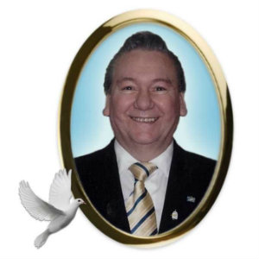
Julien Dionne
The family announces with great sorrow his passing in Sudbury, Friday, June 21st, 2019 at the age of 70 years. Loving husband of Suzanne ``Sue`` (née Laurin) Dionne of Sudbury. Predeceased by his son Rhéal Dionne (Jessica Lapointe-Dionne). Cherished grandfather of Noah Lapointe-Dionne. Beloved son of the late René and the late Leda (née Gervais) Dionne. Dear brother of Edna Gaudreault (late René) and Richard (Lucienne). Predeceased by his siblings Lucille Legault (late Gaëtan) and Donald (Pauline). Lovingly remembered by many nieces, nephews, cousins and lifelong friends. Julien was a devoted union activist. He spent his career developing, coordinating and teaching Safety and Health. He was passionate in all his endeavors. He particularly enjoyed playing his guitar entertaining others and spending time with family and friends, especially his grandson Noah. The family will receive relatives and friends at the COOPERATIVE FUNERAL HOME, 222 Lasalle Blvd, Sudbury, Thursday, June 27th, 2019 from 2 to 5 and 7 to 9:30 p.m. Funeral Mass will be celebrated Friday at 10:30 a.m. at St-Jean-de-Brébeuf Church, Sudbury. Donations by cheque or online to the Maison McCulloch Hospice, Better Beginnings Better Futures or the Sudbury Food Bank would be appreciated. www.cooperativefuneralhome.ca

